AGENDA

CULBERSON COUNTY GROUNDWATER CONSERVATION DISTRICT

REGULAR MEETING

WEDNESDAY, JUNE 18, 2025, 2:00 P.M.

at the following locations:

CULBERSON COUNTY GROUNDWATER CONSERVATION DISTRICT OFFICE

1300 W. BROADWAY STREET, VAN HORN, TEXAS 79855

ZOOM LINK: Meeting ID: 249 120 3952 Passcode: ccgcd

**REGULAR MEETING**

1. Call to Order
2. Determination of Quorum
3. Proof of Notice of Meeting
4. Public Comment
5. Discuss/Act On: Approval of Minutes
   1. APRIL 9, 2025, REGULAR MEETING
6. Discuss: Update on TWDB “2025 Ag Water Conservation Grant”
7. Discuss/Act On: General Manager’s Report
   1. Field Tech Report
   2. Information/Meetings
   3. Lobo, Wildhorse, Michigan Flat water levels
8. Discuss/Act On: Payment of Bills, and Bank Reconciliations
9. Discuss/Act On: Next Meeting Agenda Items, and set July meeting date
10. Discuss/Act On: Lobo Aquifer
11. Public Comment
12. Adjourn

"Culberson County Groundwater Conservation District reserves the right to convene in Executive Session on any agenda or discussions items if discussion of said items falls under the exceptions listed in Chapter 551, Texas Government Code, known as the "Open Meetings Act". l, the undersigned authority of the District, do hereby certify that the above notice is a true and correct copy of said notice and that such notice was posted on the main entrance of the District hearing and located at 1300 W Broadway, Van Horn, Texas, at least 72 hours prior to the time of said public hearing, and posted on district website www.ccgwcd.org at least 72 hours prior to the time of said hearing.”

__JULY 13, 2025_________________ DATE

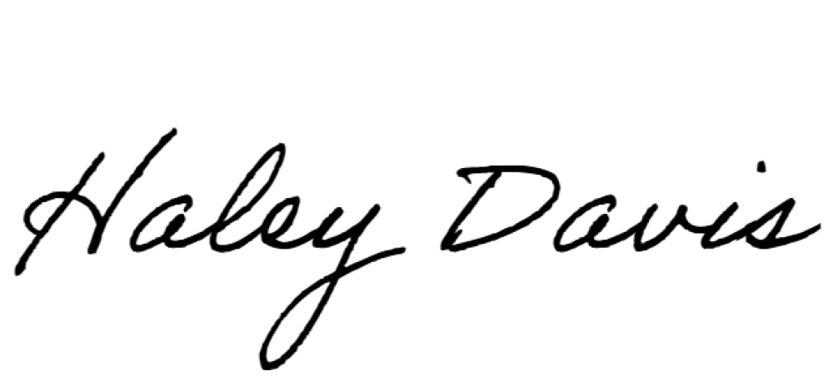__________________________________, HALEY DAVIS- GENERAL MANAGER