AGENDA
CULBERSON COUNTY GROUNDWATER CONSERVATION DISTRICT
REGULAR MEETING
WEDNESDAY, NOVEMBER 12, 2025, 2:00 P.M.
at the following locations:
CULBERSON COUNTY GROUNDWATER CONSERVATION DISTRICT OFFICE
1300 W. BROADWAY STREET, VAN HORN, TEXAS 79855
ZOOM LINK: Meeting ID: 249 120 3952 Passcode: ccgcd

REGULAR MEETING
- Call to Order
- Determination of Quorum
- Proof of Notice of Meeting
- Public Comment
- Discuss/Act On: Approval of Minutes
  - OCTOBER 8, 2025, REGULAR MEETING
- Discuss: Proposed Changes to Management Areas
- Discuss: Management Plan Update
- Discuss: DFC Updates and Strategies
- Discuss/Act On: General Manager’s Report
  - Field Tech Report
  - Information/Meetings
  - Wildhorse, Lobo and Michigan Flat water levels
- Discuss/Act On: Payment of Bills, and Bank Reconciliations
- Discuss/Act On: Next Meeting Agenda Items, and set January meeting date
- Discuss/Act On: Lobo Aquifer
- Discussion with Steve Finch on any updates
- Public Comment
- Adjourn
"Culberson County Groundwater Conservation District reserves the right to convene in Executive Session on any agenda or discussions items if discussion of said items falls under the exceptions listed in Chapter 551, Texas Government Code, known as the "Open Meetings Act". l, the undersigned authority of the District, do hereby certify that the above notice is a true and correct copy of said notice and that such notice was posted on the main entrance of the District hearing and located at 1300 W Broadway, Van Horn, Texas, at least 72 hours prior to the time of said public hearing, and posted on district website www.ccgwcd.org at least 72 hours prior to the time of said hearing.”
__November 6, 2025_________________ DATE
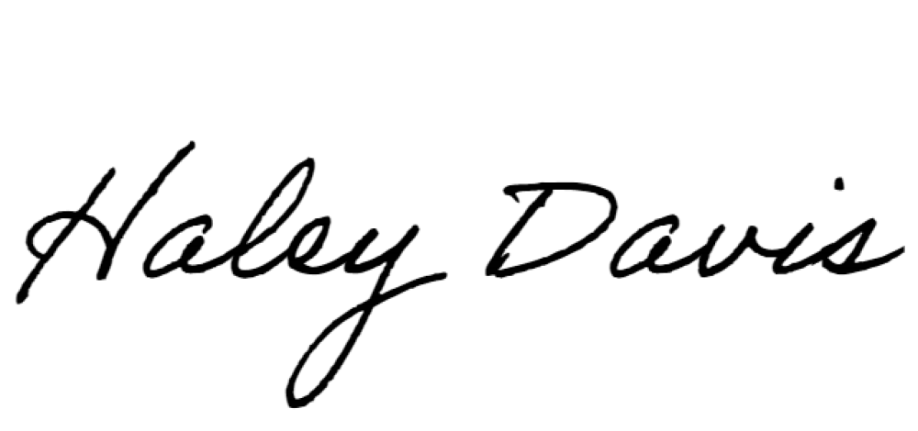
__________________________________, HALEY DAVIS- GENERAL MANAGER

